|  |  |  |
| --- | --- | --- |
| **COMSATS University Islamabad**  **Sahiwal Campus** | | |
| **Department of computer science** | | |
| **Class Assignment # 4** | | |
| **Subject:** Programming Fundamentals | **Couse code:** CSC103 | **Due date:** 27/05/2024 |
| **Instructor:** M. Khurram Nisar | **Class:** FA23-BCS-E | **Total marks: 5** |

Note: You need to develop and run these programs of your own. I may conduct viva/quiz to verify if programs are actually written by you. Failure to show understanding of code, copied assignment and code written using AI tools will yield 0 marks.

1. Write a C++ program that swaps 2 numbers with call by value and call by reference with the use of functions and explain the results.
2. Write a C++ program that identifies an identity matrix, it is a matrix with all its diagonal elements equal to 1, and zeroes everywhere else.

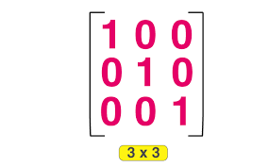

1. Write a C++ Program that performs addition of two matrix in 2-dimensional array.

1. Write a C++ Program to print this pattern.

1 2 3 4 5 6

1 2 3 4 5

1 2 3 4

1 2 3

1 2

1